**Time Buffer Levels on an Ethical and Effective Surgical Floor**

Kangwon Seo, University of Missouri, Columbia, Missouri, 65203 United States of America

Michael Stroud: University of Missouri, Columbia, Missouri, 65256 United States of America

Joshua Freeman: University of Missouri, Columbia, Missouri, 65265 United States of America

Sai kiran Singraj: University of Missouri, Columbia, Missouri, 65203 United States of America

Madeline Easley: University of Missouri, Columbia, Missouri, 65203 United States of America

Hyunho Oh: University of Missouri, Columbia, Missouri, 65203 United States of America

**Problem Description 1**

The goal of this case study lies in the configuration of the surgical floor. Various factors such as surgeon number, quantity of pre-op rooms etc. have been provided, however the factors of patient schedule and support staff have not been provided. The goal of this case study is to search through unknown factors with the goal of identifying a model that simulates an ethical and “most effective” surgical floor.

A detailed understanding of the problem was acquired from four sources namely, literature review and takeaway analysis, 4W’s analysis, current to future analysis, and metric information analysis. Literature review analysis provided much needed context of the health care field. 4W’s analysis provided us with a structured way to think about the broader implications of our work. Current to future state analysis helped us identify many attributes of a “most effective” system. Metric information analysis began the mathematical foundation of our study. In the following paragraphs, 4 problem description techniques are used to gain insight into the surgical floor.

Problem Description, Literature Review Analysis

Health care services are a service in which providers and customers (patients) interact to produce and consume at the same time, and if supply and consumption consist of an asymmetric structure, patients will have to wait.  Unlike other services, Health care services are essentially a service that treats patients, and waiting time is an important factor in that it deals with human life.

Comas, M. et al (2008) conducted a study to select patients' priorities according to waiting time. Their study focused on Cataracts and lens opacity. In developed countries, the prevalence of cataract is high, especially among the elderly thus, the volume of need and demand for surgery is too great for current supply, and waiting lists arise. The result of delayed surgery in developed countries is visual disability associated with moderate to low levels of visual acuity; however, in less developed countries, delayed surgery may lead to blindness. Comas, M. et al (2008) suggest prioritization system for waiting lists. The priority selection criteria were based on the patient's criticality, not the hospital arrival time. Introducing a prioritization system for waiting lists was more beneficial than allocating surgery by waiting time only (FIFO) and the proportion of patients penalized with excessive waiting times was small and had low priority. This alternative would make waiting list management transparent, would ensure that the waiting time of the most disabled patients is extremely reduced, and may be a less costly and more sustainable option than shock plans (Comas, M. et al., 2008).

Problem Description, Literature review takeaway

Reducing patient waiting time is thought to be possible by increasing utilization of the operating room. In our simulation model, OR room, table, and surgical cases are fixed. Ferreira, R. B. et al suggest that the introduction of flexible scheduling and an increase in post-anesthetic beds (PABs) would lead to a significant improvement in the Surgical center’s productivity. The hospital studied is a public institution, located in Rio de Janeiro city, Brazil. Its SC has 11 surgery rooms and 7 PABs, with 12 medical specialties. In the study, PAB availability was considered as the most critical point in the system, due to the small number of vacancies relative to the number of performed surgeries, with resulting overloading problems. For a given scheduling plan (rigid or flexible), the simulation of changes in PAB numbers did not yield significant changes in the surgical room's use rates. However, the introduction of flexible scheduling allowed for a significant reduction in these rates. The observed performance improvements reflect the reduction in waiting time among patients still waiting for room scheduling, as can be seen by the reduction in patient blocking times. (Ferreira, R. B. et al., 2008).

Problem Description, 4 W’s Analysis

Who: Who has the problem?

- The healthcare world’s big problem is how to treat patients effectively while still maintaining efficiency. Surgical floors struggle to efficiently complete procedures within the constraints of time and money.

What: What is the problem?

- The primary objective of this research is to schedule a procedure in operating room scheduling optimizer simulation model as well as to decide the number of staff to have on hand when it comes to nurses as well as maintenance staff. In this project the need is to come up with the most effective OR configuration. Like optimizing revenue, number of surgical cases completed, & operation room utilization. In this project, we will be using a simulation model software called FlexSim Simulation Software.

Where: Where is the problem?

- The problem is located in a simulated surgical floor. The simulation is an amalgamation of several surgical floors and represents a generic hospital location. For this case study, the MU hospital was chosen as a specific geographical location. The model will also be constrained by MU hospital policies.

Why: Why is the problem?

- It is extremely important to address this problem as the COVID-19 pandemic and the after covid world continues to challenge healthcare systems, hospitals, and surgical floors. Every fresh wave of patients puts an additional burden on staff that are already overworked and under stress. IE practices and healthcare modeling can offer operation solutions to the medical field. Data driven healthcare leadership is crucial to maintain operations. Creative data driven healthcare solutions have mitigated many pandemic-related problems such as protecting staff and patients while upholding the mission and values of their organizations.

Problem Description, Current to Future Analysis

The current state of the operating room is quite unorganized. There is no current schedule, or system for what surgery is performed in which operating room. We are currently assuming that the hospital we are working to improve is the MU hospital located in Columbia, Missouri. The objectives of the simulation are to maximize the efficiency of the Operating Room in several ways. However, there is a gap between the current state of the OR and where we project the future state will be. The ways we can improve upon this is mostly through organization. By optimizing the order or surgeries in the schedule, and by finding the most efficient staffing amounts, and OR room assignments. While optimizing these, we also need to consider the Ethics of medicine and healthcare and lean principals.

The future state of the OR, or what we want our solution to look like, is to maximize the efficiency of the operations, as was stated before. The subsections we are including in this umbrella of “maximization” are as follows. The first being to increase the operating room utilization to ensure the OR is always helping someone. The second is to use the revenue efficiently to provide the highest quality care while within monetary constraints. The following are also goals that fall under the umbrella of OR configuration: limiting staff overtime, increasing the utilization of operating rooms, decreasing patient wait time, improving treatment of emergency patients, and keep employee hours reasonable. Figure 1.1 shows a visualization of our current state to future state analysis.

Figure 1.1

Problem Description, Metric Information Analysis

Metric information analysis was conducted to fully understand the input/output space. All team members were notified of the definition of each metric. Table 1.1 details the numerical results of our findings in table format.

Total Completed Surgeries: The function of the Surgical Floor is to produce treated patients at the fastest rate possible. Maximizing completed surgeries is the optimal metric we wish to gravitate toward. In our case study, we have 35 set OR operations, therefore we have a maximum achievable value of 35 patients, where our lower bound is 0 when no patients arrived that day. We cannot have negative customers.

Emergency cases show up at random and must be treated immediately on that workday. Given this metric, our system must account for the max amount of emergency cases possible. We will accommodate for an upper bound of VALUE where we have a constant stream of emergency patients to a lower bound of 0 where no emergency patients arrived.

Financial Breakdown: We have selected our Surgical Floor to be incorporated into a non-profit hospital. This means that we wish our “profit” to be equal to 0, but not under as then we could not fund the hospital for future expenditures. Mathematically, we want Revenue-Costs=$0. Utilizing the monetary resource in an efficient and effective manner will promote the Total Completed Surgeries and mitigate patient waiting times.

With this goal, it gives our system a large range of values it can take on as we can run one surgery and balance that with the costs for the day. However, running a low number of surgeries breaks the constraint we set for our Completed Surgeries (as we wish to maximize this value).

OR Utilization: We wish to maximize OR Utilization in our model as the time the OR rooms plays directly into Completed Surgeries and Revenue. The higher the OR utilization means the more people are getting the attention they need, as well as supplying funds to the hospital so they can remain operational. Utilization is the sum of surgery time and maintenance time. OR utilization can take on values between 0-100%. 0% meaning that the OR rooms were never used and 100% meaning they were constantly in use.

Staff Utilization: Staff Utilization should also be maximized. Having a high utilization means the hospital is getting the most value per time from their workers. Staff utilization can take on values from 0-100%. 0% means the workers were idle for the entire shift, conversely, 100% means our workers were always busy over the course of the shift.

Staff Overtime: To not wear our employees out, we wish to minimize Staff Overtime. By minimizing overtime, our workers can stay rested and avoid the effect of burnout, which can lead to operation mistakes throughout the day. It also will save the hospital costs from paying the $48 penalty associated with each hour of overtime work that every staff member is forced to work. Overtime will overall flatten the relationship between value per time, where we want to achieve a linearly positive correlation. Therefore, we want to set a hard bound on having a max of 90 minutes of overtime. This assumes that anything over the 12-hour workday is counted as overtime (i.e., 13 hours worked in one day is equal to 1 hour of overtime).

Patient Waiting Time: Patient waiting time is an important factor in the configuration of a surgical floor. Patients should be cared for rapidly and without excess waiting. Some patients’ waiting time is unavoidable such as the PACU recovery period, however idle patients in waiting rooms clog up the system and result in a less enjoyable experience for the patient.

Little’s Law states there exists a positive relationship between patient waiting time and patients in system. To prevent the spread of contagious diseases such as Covid-19 it is imperative to minimize the number of patients in the system and therefore reduce patient waiting time.

Table 1.1

**Ethical Limitations 2**

Ethical Limitations, Fundamental Cannons:

The National Society of Professional Engineers (NSPE) has created codes of ethics that all engineers need to consider during all their projects. The NSPE codes deliver a foundation for fairness through ethical principles so that engineers can ensure the betterment of society. Two crucial NSPE Codes of ethics to consider for our OR configuration have been identified. Underneath the fundamental cannon we explain how the specific cannon is necessary to achieve an effective model.

Fundamental Cannon #1: Hold paramount the safety, health, and welfare of the public

As a hospital, it is our number one job to provide quality care for all our customers. We must ensure that we are utilizing all our operations to their max capabilities, so that more people can be treated. Pushing people’s surgeries back because our ORs were not operating well is unethical and a solution must be sought after.

Fundamental Cannon #6: Conduct themselves honorably, responsibly, ethically, and lawfully so as to enhance the honor, reputation, and usefulness of the profession.

It is our job to produce a model that meets all criteria as best as possible. Exploring the options is our ethical duty for society, so that we can produce cured, happy patients.

Ethical Limitations, Impact on Effectiveness.

Si-MU-lation team takes ethical considerations very seriously. In determining the best OR configuration, additional constraints must be placed on the model for the sake of ethics.

Ethical limitation 1: Patient Selection. It is unethical to prioritize customers that make us the most money. All patients should be given an equal chance of being selected for surgery regardless of the patients’ finances.

Ethical limitation 2: Patient Selection. It is unethical to select patients with low expected surgical time. This would increase the number of surgeries completed per day, however if a hospital’s policy is this, then longer surgeries will always be pushed back and take many more days to be scheduled.

Ethical limitation 3: Staff Overtime. It is unethical for staff to work more than 90 minutes over their shift. Long hours are a potential danger to customers as fatigue may deteriorate performance. Fundamental Cannon #1: Hold paramount the safety, health, and welfare of the public

Ethical limitation 4: Financial policy. It is unethical to prioritize profit. The University of Missouri hospital is a non-for-profit organization and prides itself on its high-quality treatment of patients. Chasing profit might seriously affect the quality of treatment.

Ethical limitation 5: Patient Selection: It is unethical to give surgery schedule priority to patients based on inpatient, outpatient status. Both patients might require surgery with similar urgency and prioritizing one over the other will lead to inferior treatment.

**Assumptions 3**

Assumption, Performance metric priority

After deliberating and studying reference material, our team has decided on this performance metric hierarchy.

1. Maximize Operating Room Utilization: The highest priority performance metric. Operating room utilization should be kept high so that patients will always be receiving care.
2. Minimize staff Overtime: The second highest priority performance metric. Staff overtime should be kept low so that staff can.
3. Minimize patient waiting time: The third highest priority metric. From literature review, patient waiting time is an important factor in hospital performance.
4. Maximize staff utilization: The fourth highest priority metric. Idle staff is a non-value-added activity. Money spent on idle staff could possibly be spent in a more beneficial way.
5. Total Completed Surgeries: The fifth highest priority metric. Although weighted very similarly to staff utilization, total completed surgeries should not be chased after. Completing the highest number of surgeries could result in a selection bias towards less time-consuming procedures.
6. Financial breakdown: As a non-profit organization profit should not be chased except when all other metrics are already optimized.

Assumption, Feasibility constraints

After extensive analysis of the problem description, our team defined two model feasibility constraints. Models are considered infeasible if staff overtime exceeds 90 minutes. Excessive overtime is linked to a decrease in patient safety and an increase in nurse burnout. Patient safety is deteriorated because tired surgeons are more likely to make mistakes. Nurse burnout is increased because nurses who work overtime are more likely to report unhappy work and life balance. Models are also considered infeasible if net profit is negative. Non-profit surgical floors may receive some financial support from the government; however, our model is assumed to require a positive cash flow to keep the lights on.

Assumption, Rolling cases

Our team assumed that cases are rolling. Our study only accounts for a single day of operation. As not all cases can be done in a single day, we assume that unscheduled cases are put on hold until they are scheduled on a future date. We also assumed that new cases would be added to the list. The rolling cases assumption changes several ways we look at the model. With the rolling cases assumption, it makes no sense to prioritize cases that have a high dollar per minute metric. Prioritizing these cases would lead to inefficiencies in other metrics while exhausting the supply of high dollar per minute cases. With a rolling cases assumption, the case scheduling problem can be viewed as a continuous process instead of a single event.

**Methods 4**

Methods, Search through patient schedule

Patient scheduling is a complicated procedure. Using a single scheduling algorithm, we can reduce the complexity of this problem down to a single dimension, namely buffer time. By experimenting with varying buffer times, we can determine can find the optimal patient scheduling procedure for this surgical floor.

Methods, Searching through support staff

Support staff are an integral part of the surgical floor. By using flex-sims experimenter, we can find the tradeoff between profit and performance of each additional nurse. Because of our non-for-profit assumption, a nurse should be hired if the performance of the system marginally improves, and the model is feasible. Figure 2.1 shows a visualization of a simple hypothetical support staffing level selection where all models are feasible. As seen in the figure, performance increases as the staffing level increases up until staffing level 3. As staffing level increases past this point there exists no relation between performance and staffing levels. Because our model used a non-for-profit hospital economic policy, system performance is to be preferred over profit. Therefore, if money can be spent to measurably increase performance it ought to be spent. Thus, staffing level 3 should be chosen as it is the minimum number of nurses that increases the performance of the system.

Both the nursing profession and the larger health care system depend on safe nurse staffing. All nurses' capacity to provide safe, high-quality care in all practice settings is impacted by staffing. We can improve healthcare for all by doing away with risky nurse staffing practices and policies.

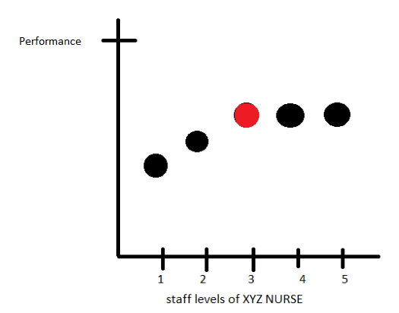

Figure 2.1

Methods, Preliminary models

Our team identified several ways to assign cases to the OR. In this section of the report, we will go over some of the algorithms and experiments done. These experiments proved valuable in interpreting the quality of the final result while also helping us discover more about the simulation.

Preliminary Model 1:

Three simulations were performed in this model. The first simulation had inputs of 100% patient workload (35 patients) and full staff. The second simulation had inputs of 70% patient workload chosen at random (25 patients) and a medium staffing level. The third simulation had inputs of 50% patients chosen at random (18 patients) and minimum nurse staffing levels. The results of the three simulations were recorded. This preliminary model helped us identify roughly the capacity of the system.

Preliminary Model 2:

For this arrangement, 30 surgical cases out of 35 have been assigned with a tendency of the order from longer cases to shorter cases, by referring to the expected surgical time. In an attempt to avoid duplicated times between successive cases, the OR rooms were allocated to each case such that they are distributed as much as possible. For example, we assigned OR1 – OR2 – OR3 – OR1 – OR2 – OR3 for the first six surgical cases. We tried to assign blocked cases first but were flexible on this. We loaded this arrangement to the simulation model and ran with the default number of staff. As a result, we could obtain $77,754 for net profit, but $12,427 overtime expenses and approximately 400 minutes of staff overtime occurred, which shows this arrangement won’t work for our purpose. Especially the last surgical case could be started after several hours after the previous case, which makes huge idle time for many staff members.

Preliminary Model 3:

One model that we developed we decided to only include 50% of all addon cases. This was an effort to accommodate for emergency cases as well as normal cases going longer than their expected time. These addon cases were then added into the pool of block cases as they were given priority. Next, we assigned all block cases to be completed first, to ensure they were completed within the working hours of the day. From having the total number of cases locked, we divided the total completion time for all cases by 3 to obtain the desired target time for each OR. This gave us a desired time constraint for each room that we could use for our room assignment operation. Now all we had to do was fill the rooms with cases. We tackled this problem by ordering the selected cases (cases toward the top of the charge we given priority) from greatest to least in terms of expected completion time. Expected completion time is the sum of the room turnover time and expected surgery time. From this list we assigned 1 of the 3 largest expected completion times to each of the ORs. After the 3 largest times have been assigned to each room, we do the same operation, however, for the 3 shortest expected completion times. Following these rules each OR should now have 1 long case and 1 short case. From here we repeated this assignment pattern of long-short-long-short until all cases have been assigned.

From this model we discovered that even with only 50% of the cases included we went well over our target time for our surgical floor. Along with that the assumption of cases toward the top of the list being prioritized did not search cases below the 50% threshold. This could lead us to have a large degree of missed opportunities in our final selection.

Preliminary Model 4

A preliminary experiment was conducted to confirm suspicions about the working of the model. Most surgeons in the model are named, such as Doctor Smith, however, inside the surgeon column Gen Surgeons was listed. Our team was confused on how to schedule the generically named surgeons, such as Gen Surgeons, Vasc Surgeons etc. Our initial interpretation of the generically named surgeons was it referenced another surgeon, however this turned out to be false. By looking inside the FlexSim model, we noticed several surgeons whose names were not inside the excel master file. By performing a single case day and noting the nametag on the doctor it was concluded that the generically named surgeons could be treated as independent doctors.

Methods, Time Buffer

An experiment for time buffer was selected after preliminary models were discussed. In our preliminary models our team found it was difficult to schedule the correct amount of work for the surgery center. However, scheduling work should consider mean and variability across many replications. In figure 2.2, a hypothetical non-buffered system is compared to a hypothetical buffered system along an x-axis of time. The red curve denotes the non-buffered system make-span while the blue curve denotes the buffered system make-span. The horizontal lines denote important times for our model. The black horizontal line denotes the 12 hours that our model should run for, while the green line represents the maximum ethical run time of the model. The non-buffered system in red has its mean make-span centered at 12 hours, however a very large portion of the curve exceeds the maximum ethical run time of the model. Therefore, the non-buffered system should not be actualized for ethical reasons. Now look at the buffered system in blue. The buffered system has a much lower mean make-span at around 7 hours, however almost no part of the curve is past the maximum ethical run time of the model. This buffered system is the perfect buffered system because the mean is positioned in such a location that all of the curve is feasible, yet the mean make-span of the system is maximized. Maximizing system make-span allows for more slack in the time resource. In short, to account for variability in the model, our model needs a time buffer to remain feasible throughout the entire bell curve. The proceeding paper attempts to find an OR configuration that resembles the blue curve in its property of sitting as close to the infeasibility limit as possible.

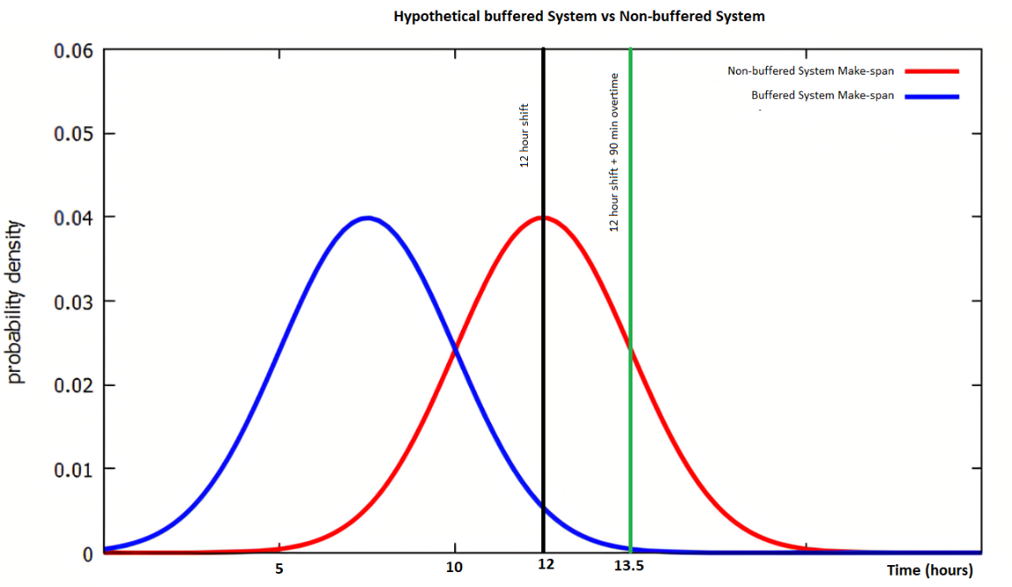

Figure 2.2

An algorithm needed to be constructed to create a feasible, yet maximally performing system. Our team wanted this algorithm to work for any future cases because of our rolling cases assumption. In relation to Figure 2.2, we needed a reliable way to shift the system’s make-span left or right until the system’s make-span was minimized while still remaining feasible.

Methods, Case Splitting

Case splitting refers to the division of cases into the three ORs. The importance of case splitting can be easily understood through discussing the critical path. Critical paths in this study are the list of cases that enter in a specific OR. In figure 2.3 the critical path is OR 3. While OR 1 and OR 2 might have numerically more cases, the surgeries in OR 3 took longer or experienced delays. At the end of the day, surgeons and nurses all had to wait on OR 3 to finish work. Colloquially OR 3 is known as the limiting factor or the bottleneck. Minimization of the bottleneck is paramount in system configuration.

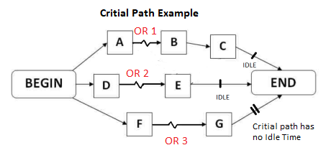

Figure 2.3

Methods, General Algorithm

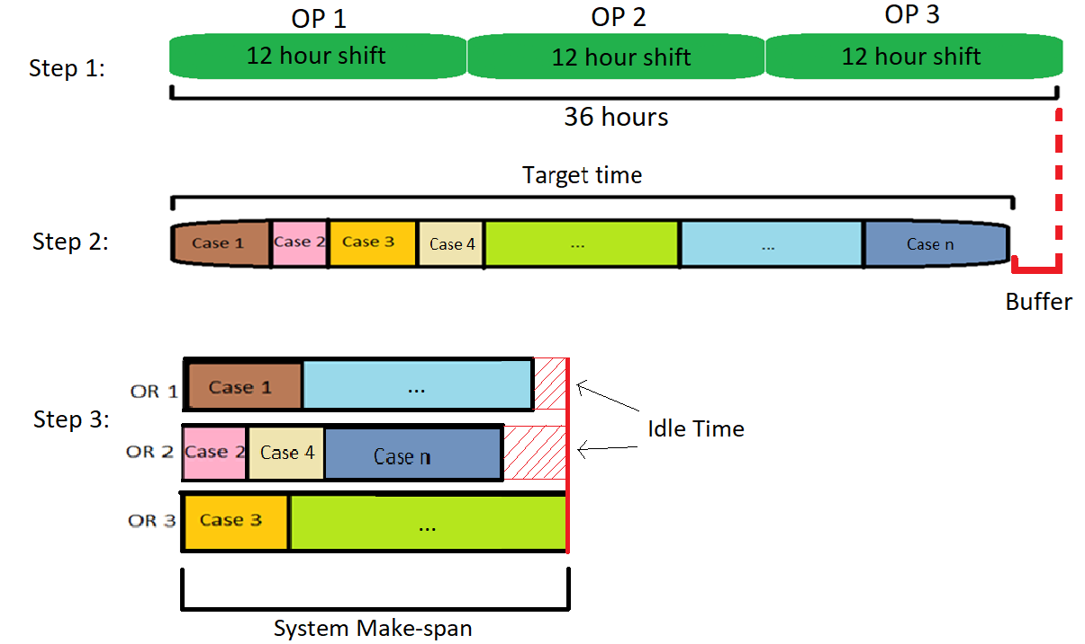

Figure 2.4

Figure 2.4 shows the general process to produce case selection, case splitting, case ordering. Figure 2.4shows each block taking a time that is proportional to its length. In step 1, we make assumptions about the three operating rooms. The important assumption shown in this step is the 12 hours shift assumption. In step one, we have laid out three shifts in series to help visualize the capacity of the system. Step 2 performs case selection. Case selection can be interpreted as selecting the cases to accept into the surgical floor via filling out the row in the surgical cases excel file. In step 2, we find a list of cases whose expected case time sums up to a specified value or target time. From this target time, we can calculate the buffer time by simply subtracting the target time from 36 hours. Step 3 performs case splitting and case ordering. In the third step, the selected cases from step 2 are split into three categories each corresponding to their respective OR. From case splitting there are many ways to assign the cases into three categories. However, from understanding the critical path, it can be seen that we want to minimize the critical path to minimize the idle time for the other operating rooms. Case slitting can be interpreted as filling out the “OR_Suite” column in the surgical cases excel sheet. Step three also performs case ordering. Case ordering is done via a next-to-finish procedure. The next-to-finish procedure is performed as follows. First, we look for the soonest to start case. If two cases are to start simultaneously, we select the case that belongs to the longest OR category as the next entry in the case ordering. For example, in the scenario in figure 2.5, Case 1, Case2, and Case 3 all begin simultaneously so we select the case that belongs to the longest OR category. Case 3 belongs to the OR category with the longest length. This can be interpreted as case 3 being ordered as 1st in the surgical cases excel sheet. Now Case 2 and Case 3 begin simultaneously so we select the case that belongs to the longest OR category. Case 1 belongs to the OR category with the longest length. This can be interpreted as case 2 being ordered 2nd in the surgical cases excel sheet. This process was done for every selected case to achieve this configuration.

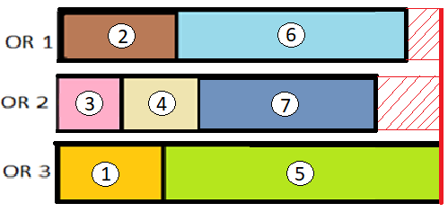

Figure 2.5

Methods, Algorithm Implementation

The length of time that each case is a distribution, however we can approximate this distribution by using the expected surgical time and expected turnover time. In our study, we used the columns of Expected_surgical_Time and Expected_Turover_Time to create a new column called the expected case time. Figure 2.6 shows how the expected case time was created. From expected case time, we can begin to start the case selection process

Table 2.1

Case selection was performed in a simple way. After identifying a time buffer, the list of expected case time for all potential 35 cases was put into a python program that found many lists that contained every combination of the expected case times. A sum was computed for every list. Then by sorting the sums, we could find the list of expected case times that closely coincided with our time buffer. Where closely coincided meaning within 10 minutes of our target time.

Case splitting was also performed using python. We selected all of the lists of expected case times that closely coincided with our time buffer and split them in every possible way. This gave us another large list to sort through. To measure how well the cases were split we used a sum of squares to find the error between the length of the three operating rooms. We then sorted the new list by the smallest sum of squares error. The list of expected case times that output smallest sum of squares error as the “best” ordering for the buffer level.

Following the creation of the “best” OR ordering list, while we had selected the number of cases that best fit our target time, the order in which the cases were carried out still needed to be determined. For this we chose to visually represent our split cases within a Gantt chart, to identify where gaps were created due to doctors being double scheduled across the 3 ORs. To accomplish this, we created projected Gantt charts in AutoCAD. With these projected Gantt charts we could specifically see if the same doctor was double scheduled across ORs easier, and we could swap doctor-specific operations to minimize the overlap between the ORs.

Figure 2.7 shows the 50% buffer projected Gantt chart. To accomplish these charts, we designated horizontal lines to represent the completion time for the total surgical operation time. For reference, 1 unit of length in our AutoCAD represented 1 minute. In the end, we would have 3 horizontal lines that each represented a separate OR. All of these lines started from the same vertical line in order to ensure all ORs started at the same time. Then, all the induvial surgical cases within an OR were inserted horizontally, back-to-back (no gaps where a gap represents idle time). When an OR was assigned to all their cases, we would start the next OR directly below the previous one. After the creation of all the OR lines, we would then go and label all of the operations with the doctor or doctor group that was assigned the operation. From this, we were able to see where doctors were double scheduled. In the case of an overlap of the same doctor, we would shuffle the cases around by replacing doctors with less frequent activities there and moving the double scheduled doctor elsewhere. From this manual shuffling we were able to decrease the overall idle time.

Figure 2.7

Methods, Binary Search

Binary search is a searching algorithm that repeatedly divides an input search interval in half to find the best solution in the solution space. We used binary search in our study by repeatedly dividing the search interval of time buffer to find the best solution in the solution space. Figure 2.8 shows a generic process of binary search. Binary search initial chooses a value as an input, in the generic process 14 was chosen as an input, based on the output solution, a direction can be inferred. In our study, an initial input of 0%-time buffer was assumed for the first iteration. In our study, an output of nurse overtime > 90 minutes led to the next iteration having decreasing time buffer, while an output of profit < 0 resulted led to the next iteration having increased time buffer. Each successive iteration of binary search reduces the search interval from 1/2 to 1/4 to 1/8 etc. approaching 0. Our study performed 5 iterations of binary search because of the diminishing usefulness of additional iterations.

Figure 2.8

**Results of Experiment 5**

Figure 3.1 shows the results of our binary search experiment. Due to our methodology, actual buffer percent and theoretical buffer percent are very similar in each iteration. Iteration 1, with an input of 0% buffer time yielded an infeasible configuration. Iteration 2, with an input of 50% buffer time yielded a feasible configuration. Iteration 3, with an input of 25% buffer time yielded an infeasible configuration. Iteration 4, with an input of 0% buffer time yielded a feasible configuration. Iteration 5, with an input of 31.25% buffer time yielded a feasible configuration. For a full review of the experimentation report please view the attached html file.

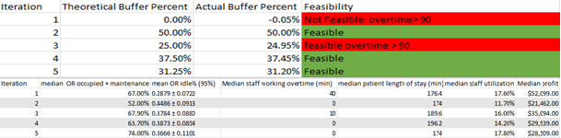

Figure 3.1

Results of Experiment, Binary Search Iterations

Our study performed 30 replications to achieve the following performance metrics on each of the iterations.

Binary search iteration 1: The 0% buffer configuration yielded a median OR utilization of 67.0% with a median staff working overtime of 40 minutes. The median patient length of stay was 176.4 minutes, and the median staff utilization rate was 17.6%. The profit was $52,099.00. However, this model was infeasible because some of the replications had staff working more than 90 minutes of overtime.

Binary search iteration 2: The 50% buffer configuration yielded a median OR utilization of 52.0% with a median staff working overtime of 0 minutes. The median patient length of stay was 174 minutes, and the median staff utilization rate was 11.7%. The profit was $21,462.00. This model is feasible.

Binary search iteration 3: The 25% buffer configuration yielded a median OR utilization of 67.9% with a median staff working overtime of 10 minutes. The median patient length of stay was 189.4 minutes, and the median staff utilization rate was 16.00%. The profit was $35,094.00. However, this model was infeasible because some of the replications had staff working more than 90 minutes of overtime.

Binary search iteration 4: The 37.5% buffer configuration yielded a median OR utilization of 63.70% with a median staff working overtime of 0 minutes. The median patient length of stay was 196.2 minutes, and the median staff utilization rate was 14.2%. The profit was $29,939.00. This model is feasible.

Binary search iteration 5: Our final iteration was tweaked via our nurse staffing level technique to perform slightly better. The 31.25% buffer configuration yielded a median OR utilization of 74.00% with a median staff working overtime of 0 minutes. The median patient length of stay was 176. minutes, and the median staff utilization rate was 17.8%. The profit was $28,509.00. This model is feasible.

Results of Experiment: Nurse Staffing Levels



Nurse staffing level analysis was conducted only on binary iteration 5. According to the 10 various nurse staffing levels we have noticed that our max OR utilization was 1-0.22 = 78% for scenario 8, with 3 pre-op nurses, 5 circulation nurses, 2 scrub nurses, 3 PACU nurses & 2 maintenance staff. This result shows us that to attain good utilization efficiency, it is not necessary to put the staffing level to the maximum. Though the OR utilization is not 90% of more, but these small runs of 10 variations does provide us with the information that there is high percent of chance that instead of maximizing the staff level, just figuring out the best staff parameter we can save huge amount of money and simultaneously increase the operation room utilization.

**Conclusion 6**

Figure 4.1 shows a summary of our experimentation by simply comparing the highest priority performance metric. We performed five iterations of binary search to quickly approach the optimal solution. The red bars were infeasible based on our feasibility constraints, while the blue bars were feasible. As seen in the figure, running binary search iterations had a positive impact on the OR utilization performance metric while staying within the feasibility constraints. In conclusion, the most effective and ethical OR configuration was found with a time buffer of 31.25%. It is important to note, data for iteration 5 data was collected from nurse staffing level analysis.

Figure 4.1

Conclusion, Final solution

Throughout this entire study, we have been striving for the most effective configuration. From NSPE codes of ethics to binary search we have defined and defended our definition of most effective. We also have fulfilled the definition with our final solution. Figure 4.2 shows the OR assignment and Case scheduling order of our optimal solution. Our nurse staffing levels are the following: 3 pre-op nurses, 5 circulation nurses, 2 scrub nurses, 3 PACU nurses & 2 maintenance staff. This configuration for the surgical floor is both ethical and effective.

**Figure 4.2**

**References**

Comas, M., Castells, X., Hoffmeister, L., Román, R., Cots, F., Mar, J., ... & Espallargues, M. (2008). Discrete‐event simulation applied to analysis of waiting lists. evaluation of a prioritization system for cataract surgery. *Value in health*, *11*(7), 1203-1213.

Ferreira, R. B., Coelli, F. C., Pereira, W. C., & Almeida, R. M. (2008). Optimizing patient flow in a large hospital surgical centre by means of discrete‐event computer simulation models. Journal of evaluation in clinical practice, 14(6), 1031-1037.

**Appendix 6**

Binary search 0%: Iteration 1

Binary search 50%: Iteration 2

Binary search 25%: Iteration 3

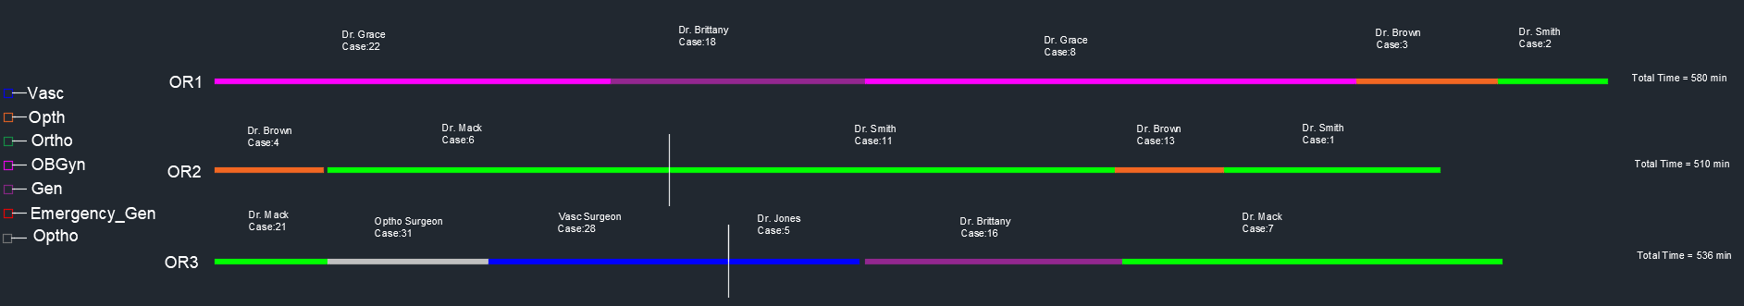

Binary search 37.5%: Iteration 4

Binary Search 31.25%: Iteration 5

